Instruction Manual for Digital Centrifuge
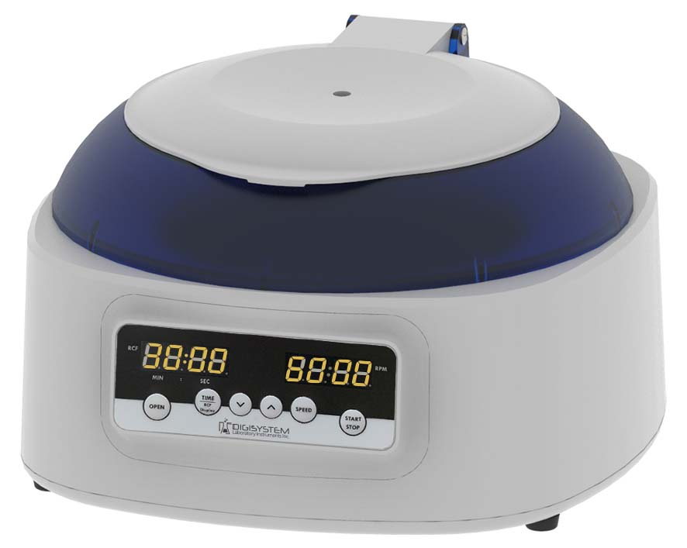
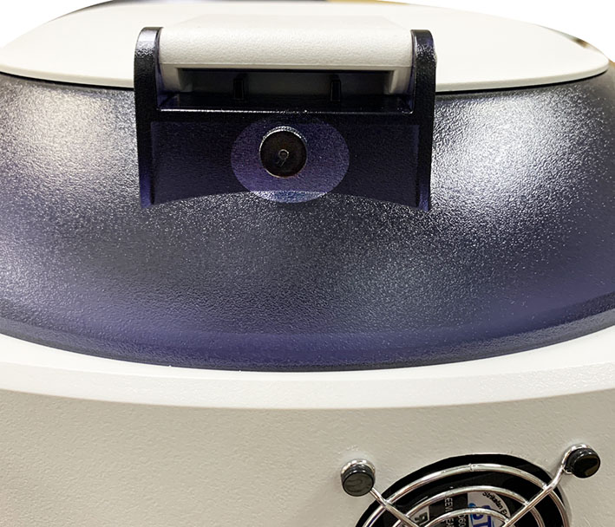
Lid

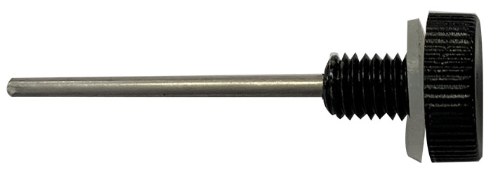
Emergency hole
Emergency tool (located at the rear of the machine.)

RCF/TIME Display

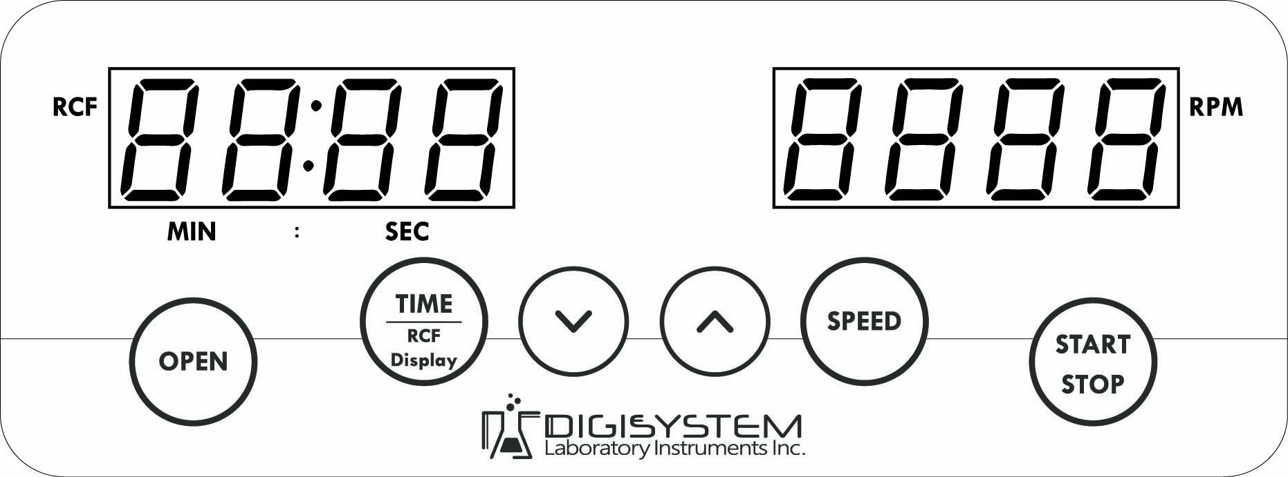
Control panel

Warnings:
* Do not open the lid before the centrifuge stops completely.
* Do not remove the centrifuge during operation.
* Do not put objects on the top of the lid.
* Do not disassemble the centrifuge by yourself. In the event of a malfunction, the centrifuge should be repaired by a qualified technician. Before repairing, turn off the power.

Steps:
- Place the centrifuge on a flat surface. Plug the centrifuge into a properly grounded outlet. Turn on the power switch behind the machine. The fan starts operation.

- Press the button to open the lid. The screen shows icon “door”. Insert an even number of tubes in a symmetrical position into the rotor.


- Put down and press down the lid. Make sure the lid is closed well. The icon “door” will disappear on the screen.

- Push the button , the speed value is flash on the screen. Push the button or to set the speed value. Push the button or any other function button to enter the speed value. When you setting the RPM value, you can monitor the RCF value on the RCF/TIME display screen.

- Push the button , the time value is flash on the screen. Push the button or to set the time value. Push the button or any other function button to enter the time value.

- After setting parameters, push the button to start the centrifuge. During operation, you can push the button to stop the centrifuge. During operation, you can push the button to switch the remaining time or RCF value on the RCF/TIME display screen.
- Under the conditions of power failure or the open function failure, please insert the “Emergency tool” straightly into the hole in the front of centrifuge to the end and push it to the right to force the lid open. (“Emergency tool” is located at the rear of the machine. When you need to use it, please turn it Counterclockwise to take it out. After finishing, please return it to the original position.)

Maintenance and care:
- Keep the centrifuge clean all the time. Cleaning can be done with a damp cloth. Avoid the use of solvents as they may damage the product housing, rotor.
- Check if the rotor is in the center. In case, the rotor is slanted. Stop using machine and contact the distributor for repair.
Circuit Diagram
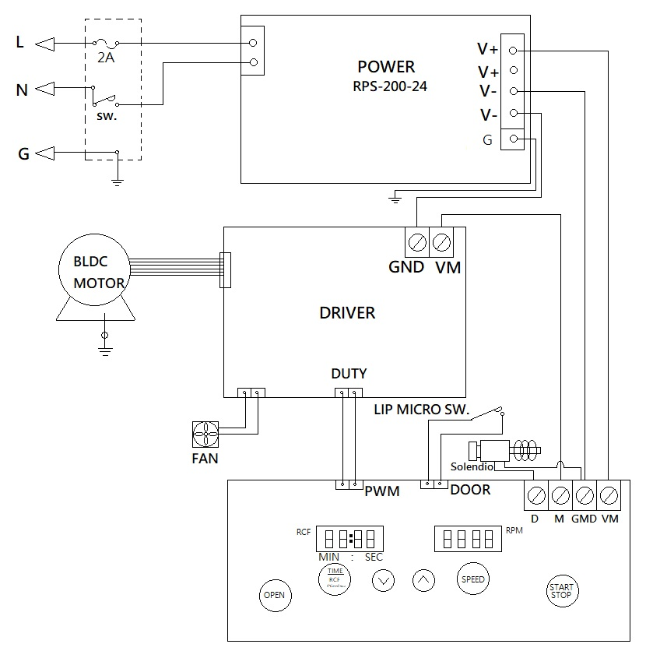

Service Manual

Troubleshooting Guide
Caution: Always disconnect the power cord before troubleshooting.
Trouble / error message | Cause | Remedy
Motor doesn’t work  (Error message : Er-P) | - Power supply is defective.  - Motor is defective.  - PC board is defective. | - Contract the distributor for repair.  - Contract the distributor for repair.  - Contract the distributor for repair.
Lid open error  (Error message : Er-d) | - During operation, the lid is open. | - Waiting for the motor stop completely. And close the lid.
Error message: run | - When the motor is rotating, push the START/STOP button. | - Waiting for motor stop completely, and then restart the centrifuge.
No display on the screen | - Power is off.  - Dead power output.  - Burnt fuse.  - PC board is defective.  - Power supply is defective. | - Turn on the power.  - Change to a different output.  - Replace a new fuse.  - Contract the distributor for repair.  - Contract the distributor for repair.
Burnt fuse | - Fuse is wasted.  - Power supply is defective. | - Replace a new fuse.  - Contract the distributor for repair.
Remark: To clear the error message, please turn off the power.

